A crap tutorial on using multiport for your eaglercraft server.
Created By FNAF69
Multiport was a tool created by Ayanami2000 which allows you to play a vanilla paperMC server in eaglercraft, this makes setting up a server much easier and there is much more documentation on PaperMC server setup than Eaglecraft server setup.Note: this will NOT work on replit, Replit is weak garbage and can’t handle mc 1.17 servers. I've tried my best to simplify this . 1. Making a PaperMC server. This will be very short as there are thousands of tutorials on creating a paper server, first, you can download paperMC from this link now. Also, please make sure you have JAVA 8 and JDK 16+ or else this will not work, you can check this in the command prompt by typing java -version . When you have your paper server installed I recommend making a dedicated folder for it as it creates a lot of crap when you use it. Now, to start Paper create a new text file and call it run or something, In here you must type

@echo off
java -Xms2G -Xmx16G -jar paper-1.17.1-411.jar
Pause

You can replace the 16 with any amount of ram you want your server to have. Now save this as a .bat file or a .sh file if you're on a unix based os (OSX/linux). When you run this your server should start up (you can join from vanilla 1.17.1 on your device by typing localhost as a server ip). The thing is, eaglecraft is on 1.5 and your server is on 1.17.1, this problem can be easily solved by downloading the ProtocolSupport plugin (You can download it here). Now, put the .jar file in the plugins folder that your paper server made, protocolSupport should work and you can join via localhost from vanilla MC versions 1.17.1-1.4 now.
2. Setting Up and installing Multiport. Now to actually be able to play this on Eaglercraft, you need multiport. Note I really screwed up and forgot to install nodeJS, you have to install nodeJS for multiport to work, (you can get node here).
Now you can download Multiport here and extract it, put the multiport folder in the folder your paper server is in. Inside Multiport you have to change 2 files, 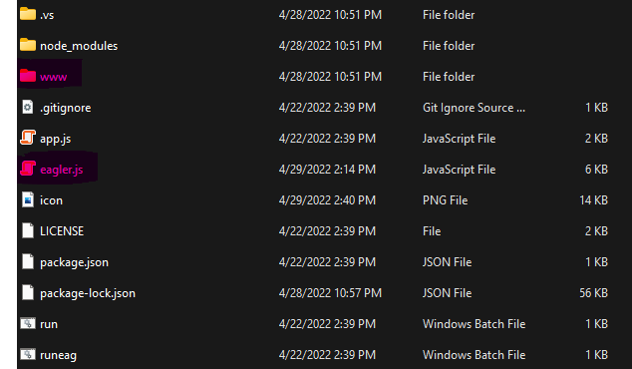
Unless you want players to play on Ayuncraft and with TooManyItems, replace the www folder with the web folder from the latest stable download of Eaglercraft and name it www.
If you try running multiport and your server at the same time You will get an error that port 25565 is in use. To fix this, open Eagler.js in a text editor and change ListenPort to 80 and Mcport to 25569 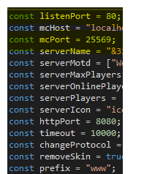
If your still getting issues, go to your paper server folder and open the Server config file and make sure ServerPort says 25569 . Save both eagler.js and the server config file and close them. Now, run runeag and run in Multiport, also restart you paper server. Now if everything works, you should be able to join your server on Eaglercraft by going to localhost:25565 .
3. Port Forwarding and domain setup
While your server is joinable via a URL, localhost means that only people on your Local Network can join.To allow your server to be accessible on the public internet, you have to open a port on your router. Note: the way I'm explaining port opening is how it works for most routers. If you're using a router with a different method , you can find it out somewhere else or watch this video here on port forwarding .
Port forwarding technically means allowing public network access to a locally hosted file (Websites, gameservers etc.) In this tutorial I'm using cloudflare, so we only need to open 1 port. First: find your router's access page. It's usually 192.168.1.1 , if not you can type ipconfig In command prompt. Now log into your router on an administrator account (usually the default account). Normally, you should find a page called (Port Forwarding/Port Triggering) If not find a menu that looks like this.
Now find a button that says something like Add service or add rule.
First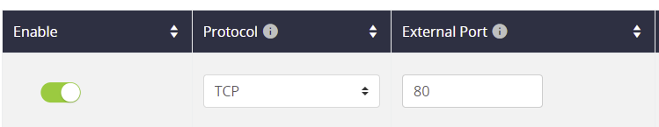
Set Enable to true(So this port is open). Next under the protocol tab, set that to TCP, Because we're using CloudFlare, we don’t need HTTPS, so set the external port to 80.
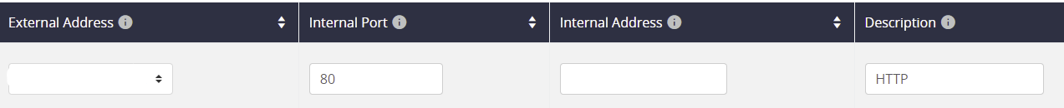
Now set the External address to your public Ip, If you don’t know that, go to https://whatismyipaddress.com/ . And copy your Ipv4 (Please Please do not use a VPN ip, cloudflare will do that for you and your server will not work if you're using a VPN). The internal port is a strange one and is usually the same as the external port, so set that to 80. Now for your Internal address, this should be your device's Local IPv4. You can find this using the ipconfig command in the terminal. 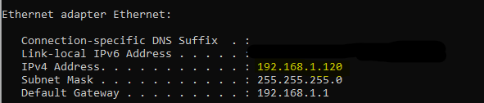
Finally set the Service name to HTTP and click add/save rule.
Now, your server is accessible on the open internet, you can join it by typing your public IP:80 into your browser. Now most people don’t want to share their IP address with everyone and also just so people don’t have to type a weird string of numbers to join your server were going to link a custom domain to your ip using CloudFlare.Its fairly easy to do assuming you own a domain.
First log into your CloudFlare Account, or make one. Now click add site on the dashboard homepage 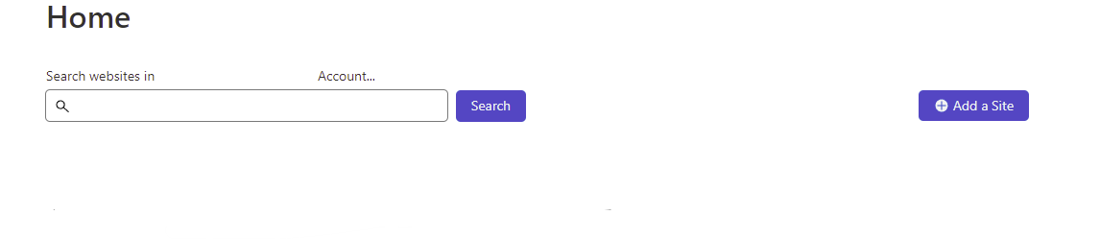
And click Add site. Now, type a domain you own and want for your server. If cloudflare wants you to change nameservers for your domain, you can do that on your domain Registrar's website. Now find the DNS settings link on your domain statistics 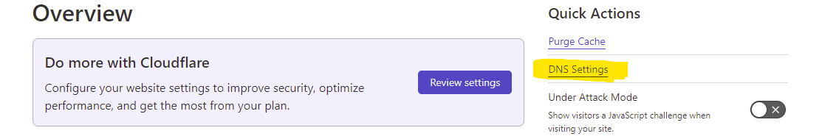
.You should see a page that lists dns records for your domain. 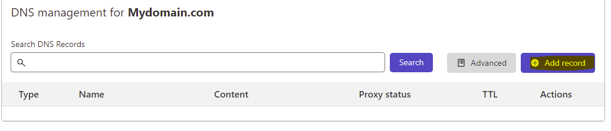
On this menu type the following
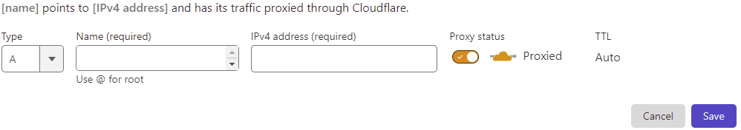
First: set the record type to A which is the default on CloudFlare. Now, set the name to whatever subdomain you want (Note this is the steps for adding the EaglercraftIP, not the vanilla one). Now: set the IPv4 to your public IP and set proxied to enabled (so people can’t use whois to find your ip). Now save this record. Note: some nameservers take a while to update so if your domain doesn't work, that’s why. Now you can go to eaglercraft via your custom domain, but unlike other people, anyone on your local network will have to type localhost as the server ip instead of wss://yoursubdoamin.yourdomain.domainending. You can test the domain by using a proxy like croxyproxy and join your server from a different IP.Now in order to allow vanilla players to join, you can’t do the same thing as for Eaglercraft. Vanilla MC will not work with proxied Cloudflare and requires the unproxied domain.
4.Allowing Vanilla players to join.
Since you can’t proxy the vanilla ip we will use a tunnel service to hide the IP while allowing vanilla players to join. In this tutorial, I'm going to use playit.gg as it’s really easy to use. Now first create an account and download their program. When the program executes you will be taken to this page. 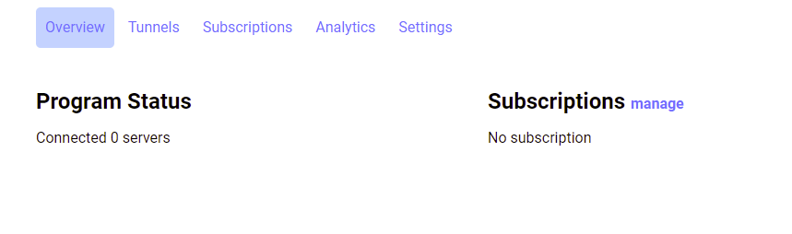
Now go to the tunnels tab and click the custom tunnel option.
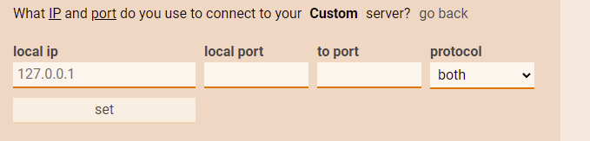
First, leave the local IP as is. Now, set the Local port to 80 which is the port your server is on.
Leave the to port as playit sets this itself. Now: set the protocol to TCP. Now click set.
On your tunnel list, copy the url that Playit generates for your tunnel.
Next, head back to CloudFlare and add a second dns record to your domain.
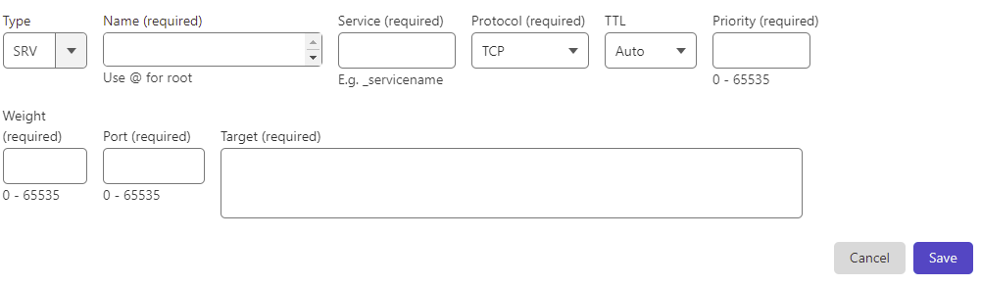
This time Set the type as an SRV record, and the name as whatever subdomain you want vanilla players to join with (can’t be the same as the eagle one). Now for the service name, set that to _minecraft . For the protocol set to TCP, leave TTL as auto and prio as 0. Now, set the weight to 5 and the port to the port ending of your playit domain, in my case its 12552. Now, set the target to your playit domain excluding everything beyond the :. Now you can save your record. At this point, you're finished with the basics of setting up Multiport, and vanilla players can join with yourothersubdomain.yourdomain.ending and Eaglercraft players can join with yoursubdomain.yourdomain.ending .

